Aquaculture CDE Test Bank

MULTIPLE CHOICE

1. Turbidity is
a. | A measure of water clarity and light penetration | c. | The -log of the hydrogen ion concentration
b. | The levels of calcium and magnesium dissolved in the water | d. | The levels of carbonate buffer dissolved in the water

ANS: A PTS: 1

2. The dissolved oxygen is at its lowest level in a lake or pond
a. | at noon | c. | at midnight
b. | at sunset | d. | at sunrise

ANS: D PTS: 1

3. The limiting nutrients in Freshwater systems is
a. | Nitrogen | c. | Potassium
b. | Phosphorus | d. | Calcium

ANS: B PTS: 1

4. The process of photosynthesis and respiration:
a. | are responsible for daily fluctuations in the pH of a lake | c. | are performed by all plants and animals
b. | are responsible for daily fluctuations in the DO of a lake | d. | all of the above are correct

ANS: B PTS: 1

5. All of these processes are part of the nitrogen cycle except
a. | Assimilation | c. | Nitrogen fixation
b. | Nitrification | d. | Ammonification

ANS: A PTS: 1

6. The state with the greatest diversity of Freshwater mollusks is
a. | Alabama | c. | Tennessee
b. | Mississippi | d. | Hawaii

ANS: A PTS: 1

7. The state with the greatest freshwater fish diversity is
a. | Alabama | c. | Tennessee
b. | Mississippi | d. | Georgia

ANS: A PTS: 1

8. The correct order for plankton from smallest to largest is
a. | Macro-plankton, meso-plankton, micro-plankton, nano-plankton, pico-plankton
b. | Pico-plankton, micro-plankton, nano-plankton, meso-plankton, macro-plankton
c. | Nano-plankton, micro-plankton, meso-plankton, macro-plankton, pico-plankton
d. | Pico-plankton, nano-plankton, micro-plankton, meso-plankton, macro-plankton

ANS: D PTS: 1

9. The term nekton refers to organisms that
a. | Live in the water column and move around freely
b. | Live on the bottom and don’t move well
c. | Live on the bottom and move around freely
d. | Live near the shore in and out of the water

ANS: A PTS: 1

10. The most accurate (true to life) indication of energy flow through the ecosystem is:
a. | Food Chain | c. | Food Web
b. | Food Pyramid | d. | Food Matrix

ANS: C PTS: 1

11. The overall amount of energy flowing through an ecosystem that is available to the next trophic level
a. | Increase by about 10% at each successive trophic level.
b. | Decrease by about 10% at each successive trophic level.
c. | Increase by about 90% at each successive trophic level.
d. | Decrease by about 90% at each successive trophic level.

ANS: D PTS: 1

12. Ecology is best defined as:
a. | Organisms and how they interact with each other
b. | Organisms of the same species and how they interact with each other
c. | Organisms and how they interact with their environment
d. | The physical and chemical characteristics of lakes, ponds, and rivers.

ANS: C PTS: 1

13. Which is true regarding the status of world wild caught fisheries:
a. | The weight of fish harvested from the oceans is relatively stable
b. | The numbers of large size, high value fishes caught has greatly decreased
c. | Aquaculture is required to meet world seafood demand
d. | Most fish species are currently regulated and are recovering

ANS: B PTS: 1

14. Maximum sustainable yield is:
a. | The number of fish that can be harvested from the oceans.
b. | The number of fish that can be harvested from the oceans each year.
c. | The number of a particular fish that can be harvested from the oceans each year without decreasing the overall population.
d. | The number of a particular fish that can be harvested from the oceans each year that would allow for the fish population to increase.

ANS: C PTS: 1

15. Commercial fishing as it is currently practiced is
a. | As a whole less sustainable than aquaculture
b. | Less sustainable than aquaculture and environmentally damaging
c. | Is for the most part environmentally friendly
d. | Is for the most part environmentally damaging

ANS: B PTS: 1

16. Which of the following is not a characteristic of a sustainable fisheries species.
a. | A fast growth rate
b. | An early reproductive age
c. | A high reproductive rate
d. | All of these are characteristics of a sustainable fisheries species

ANS: D PTS: 1

17. Which of the following is an indication that a recreational pond is bass crowded?
a. | Large number of bluegill 3-5”
b. | Bass population contains only a few large individuals.
c. | Large numbers of similar sized LMB (less than 12 inches)
d. | Lots of very small bluegill less that 2”.

ANS: C PTS: 1

18. Characteristics of a good recreational pond include all of the following except
a. | Sides with a slope of 1:2 or 1:3
b. | Solid with 80% clay content
c. | Excellent compaction of pond bottom and levees
d. | A long flat shallow area of 36 inches depth for fish spawning

ANS: A PTS: 1

19. All of the following are potentially successful strategies for recreational ponds except
a. | Largemouth Bass, Bream, and Catfish option
b. | Catfish only options
c. | Hybrid Striped Bass only option
d. | Trophy bass option

ANS: C PTS: 1

20. Aquaculture began in the country of?
a. | Japan | c. | China
b. | Thailand | d. | Egypt

ANS: C PTS: 1

21. Which country is not matched with the correct historical fact?
a. | Ancient Hawaii - Aquaculture of Pacific Threadfin (Moi)
b. | Ancient Egypt - Aquaculture of Tilapia
c. | The USA - The first aquaculture business
d. | Ancient China - The polyculture of carps

ANS: C PTS: 1

22. Which statement is not a current issue of aquaculture sustainability
a. | Carnivorous species (such as shrimp, trout, and salmon) consume more biomass (in the form of fishmeal) than is generated by their aquaculture
b. | Shrimp farms are built on mangroves
c. | Pollution created by the offshore cage aquaculture of salmon
d. | All of the above are current issues of aquaculture sustainability

ANS: D PTS: 1

23. Homer Swingle’s greatest contribution to aquaculture was:
a. | He determined that Asia had the best environment for successful aquaculture
b. | He determined that FW shrimp could be grown economically in the US
c. | He determined that Catfish could be grown economically for profit in the US
d. | He determined that Catfish and FW Shrimp could be grown economically for profit in the US

ANS: D PTS: 1

24. The largest aquaculture producing nation is:
a. | Japan | c. | Thailand
b. | USA | d. | China

ANS: D PTS: 1

25. All of the following species are aqua cultured either commercially or for stock enhancement in the US except:
a. | Shrimp | c. | Oysters
b. | Red Drum | d. | Tuna

ANS: D PTS: 1

26. Which is a reason why the US is not a more prominent world power in aquaculture?
a. | The cost of land and labor in the US is higher than most countries
b. | The lack of adequate water resources
c. | The lack of knowledge and expertise
d. | The lack of adequate infrastructure

ANS: D PTS: 1

27. A good example of intensive aquaculture
a. | Oyster ranching in the Gulf of Mexico
b. | Indoor shrimp farming in a bio-floc production system
c. | Crawfish farming Louisiana
d. | Catfish farming in the Southeast United States.

ANS: B PTS: 1

28. A good example of extensive aquaculture is:
a. | Oyster ranching in the Gulf of Mexico
b. | Indoor shrimp farming in a bio-floc production system
c. | Live Rock farming in the Florida Keys
d. | Oyster ranching and live rock farming are correct

ANS: D PTS: 1

29. All of the following are warm-water species except:
a. | Channel Catfish | c. | Tilapia
b. | Red Swamp Crawfish | d. | Striped Bass

ANS: D PTS: 1

30. All of the following states are matched with their primary aquaculture species except:
a. | Arkansas and baitfish | c. | Mississippi and catfish
b. | Florida and tropical fish | d. | Louisiana and oysters

ANS: D PTS: 1

31. They symbol “ppt” or parts per thousand is the same as:
a. | Milligrams of solute per liter of solvent | c. | Milligrams of solvent per liter of solute
b. | Grams of solute per liter of volume | d. | Grams of solvent per liter of solute

ANS: B PTS: 1

32. Increasing water temperature to lessens stress inducing levels:
a. | Increases fish metabolism | c. | Decreases feeding rate
b. | Increases fish metabolism and increases growth rate. | d. | Increase growth rate

ANS: B PTS: 1

33. Alkalinity is a measure of
a. | The amount of carbon in the water
b. | The ability of water to resist pH changes
c. | The amount of carbonate (CO³) in the water
d. | The amount of calcium and magnesium in the water

ANS: C PTS: 1

34. Hardness is defined as:
a. | The amount of sodium and potassium in the water
b. | The amount of calcium and magnesium in the water
c. | The amount of ammonia and nitrite in the water
d. | The amount of carbonate (CO³) in the water

ANS: B PTS: 1

35. Settle-able solids refers to:
a. | The solids that remain on filter paper after filtering a water sample
b. | The solids that pass through the filter paper after filtering a water sample
c. | The solids small enough to be chemically dissolved in the water
d. | The large solids that settle out in still water after about 1 hour.

ANS: D PTS: 1

36. Denitrification is
a. | The chemical conversion of nitrate to nitrogen gas under anaerobic conditions
b. | The chemical conversion of nitrate to nitrogen gas under aerobic conditions
c. | The chemical conversion of ammonia to nitrate under aerobic conditions
d. | The chemical conversion of nitrate to nitrogen to plant proteins

ANS: A PTS: 1

37. Ammonium is produced by:
a. | All of these answers are correct | c. | fish poop
b. | urine of fish | d. | uneaten food

ANS: A PTS: 1

38. All of the following are beneficial characteristics for an aquaculture species except:
a. | Fast growing | c. | Tolerant of poor water quality
b. | Prolific breeding at a young age | d. | Tolerant of high densities

ANS: C PTS: 1

39. Which species is not matched with its most common production method?
a. | Catfish - semi-intensive pond aquaculture
b. | Trout - raceway flow-through aquaculture
c. | Oysters - semi-intensive pond aquaculture
d. | Shrimp - semi-intensive pond aquaculture

ANS: C PTS: 1

40. Pond aquaculture is
a. | Less expensive (long term) and less risky than recirculating aquaculture systems
b. | More expensive (long term) and riskier that recirculating aquaculture systems
c. | Uses the most water of the primary aquaculture production systems
d. | Less expensive (long term), less risky and uses the more water than recirculating aquaculture systems

ANS: D PTS: 1

41. Flow through raceway aquaculture (for example Trout Culture in Idaho):
a. | Is low animal density aquaculture
b. | Requires more water volume per fish than other forms of aquaculture
c. | Releases high quality water back into rivers and streams
d. | Requires more land than pond aquaculture

ANS: B PTS: 1

42. All of the following are true of recirculating aquaculture systems except:
a. | Power outages are problematic
b. | It uses more space and water than other types of systems
c. | It is technically the most difficult type of aquaculture
d. | It is the riskiest type of aquaculture

ANS: B PTS: 1

43. The most economically viable form of large-scale aquaculture in the world is:
a. | Recirculating aquaculture | c. | Offshore cage aquaculture
b. | Pond aquaculture | d. | Flow through raceway aquaculture

ANS: B PTS: 1

44. The symbol “ppm” or parts per million is the
a. | milligrams of solute per liter of solvent | c. | milligrams of solvent per liter of solute
b. | grams of solute per liter of solvent | d. | milligrams of solvent per liter of solute

ANS: A PTS: 1

45. Decreasing water temperature to less than desirable levels:
a. | Increase metabolism | c. | Decrease feeding rates and the rate of development.
b. | Decreases feeding rate | d. | Decreases the rate of development

ANS: C PTS: 1

46. Buffering is
a. | the amount of carbon in the water
b. | The ability of water to resist pH change
c. | The amount of ammonia and nitrite in the water
d. | The amount of calcium and magnesium in the water

ANS: B PTS: 1

47. On the average, how much feed is required to produce a pound of gain in fish?
a. | 1 pound | c. | 2 pounds
b. | 1.5 pounds | d. | 2.5 pounds

ANS: C PTS: 1

48. The dogfish is an example of a
a. | jawless fish | c. | Osteichthyes fish
b. | agnatha fish | d. | cartilaginous fish

ANS: D PTS: 1

49. The _____ of a fish removes oxygen from the water and forces it through its gills -
a. | Nervous System | c. | Respiratory System
b. | Digestive System | d. | Excretory System

ANS: C PTS: 1

50. Conveys sensation impulses to a fish's brain.
a. | Nervous System | c. | Respiratory System
b. | Circulatory System | d. | Sensory System

ANS: A PTS: 1

51. Breaks down the food a fish consumes
a. | Digestive System | c. | Circulatory System
b. | Sensory System | d. | Excretory System

ANS: A PTS: 1

52. The ________ consists of intestines and kidneys and it filters waste from the blood.
a. | Digestive System | c. | Circulatory System
b. | Excretory System | d. | Respiratory System

ANS: B PTS: 1

53. The _______ is a lateral line for balance.
a. | Digestive System | c. | Nervous System
b. | Circulatory System | d. | Sensory System

ANS: D PTS: 1

54. The _______ consists of testes, ovaries, produces sperm and egg for the next generation.
a. | Digestive System | c. | Reproductive System
b. | Sensory System | d. | Nervous System

ANS: C PTS: 1

55. The _____ consists of a heart, veins, and arteries.
a. | Digestive System | c. | Circulatory System
b. | Respiratory System | d. | Nervous System

ANS: C PTS: 1

56. What is the name of the flap that covers the gills?
a. | operculum | c. | cartilage flap
b. | gill raker | d. | gill filaments

ANS: A PTS: 1

57. Which class of fish has a bony skeleton?
a. | Osteichthyes | c. | Cartilaginous
b. | Chondrichthyes | d. | Agnatha

ANS: A PTS: 1

58. When fish excrete their waste, what toxic byproduct is produced?
a. | nitrogen | c. | nitrites
b. | ammonia | d. | nitrates

ANS: B PTS: 1

59. After the ammonia is in the tank, which bacteria start to change it to something less toxic?
a. | nitrogen bacteria | c. | Nitrobacter bacteria
b. | nitrosomas bacteria | d. | ammonia bacteria

ANS: B PTS: 1

60. How are toxic nitrites changed into something safer by:
a. | nitrosomas bacteria | c. | bactorsoma bacteria
b. | nitrobactor bacteria | d. | rhizobium bacteria

ANS: B PTS: 1

61. What is one way to lower the amount of nitrates in your tank?
a. | do a partial water change | c. | remove fish
b. | add more fish | d. | lower the water temperature

ANS: A PTS: 1

62. What is the Golden Rule for tank maintenance?
a. | Remove all bacteria
b. | Do NOT overfeed
c. | Change out ALL of the water once a week
d. | Use a light

ANS: B PTS: 1

63. The activated carbon, found inside the blue filter cartridge, performs what kind of filtration?
a. | Chemical | c. | Biological
b. | Mechanical | d. | All answers are correct

ANS: A PTS: 1

64. How does bacteria affect Dissolved Oxygen (DO) in water bodies?
a. | increase DO through decomposition | c. | DO stays the same
b. | decrease DO through decomposition | d. | bacteria multiply DO by 8

ANS: B PTS: 1

65. Colder water__________________
a. | holds MORE dissolved oxygen
b. | holds LESS dissolved oxygen
c. | holds the same dissolved oxygen as warm water
d. | temperature does not affect DO

ANS: A PTS: 1

66. How does low Dissolved Oxygen levels affect organisms?
a. | Organisms go through more cellular respiration
b. | Organisms eat more
c. | Organisms decrease their metabolism to survive on lower amounts of DO.
d. | Organisms may die or must leave if levels get too low

ANS: D PTS: 1

67. What can REMOVE dissolved oxygen from the water?
a. | cellular respiration | c. | warming waters
b. | decomposition | d. | all answers are correct

ANS: D PTS: 1

68. What can add dissolved oxygen to the water?
a. | Diffusion from the air above | c. | Photosynthesis
b. | All answer choices are correct | d. | Wave and Wind Action

ANS: B PTS: 1

69. What is a good range of DO for Lake Lipsey?
a. | 0-6 ppm | c. | 4-6 ppm
b. | 1-4 ppm | d. | all answers are correct

ANS: C PTS: 1

70. Which of the following adds DO to a body of water?
a. | increasing temperature and decreasing aeration
b. | decreasing temperature and increasing aeration
c. | increasing temperature and increasing aeration
d. | decreasing temperature and decreasing aeration

ANS: B PTS: 1

71. Why are certain types of aquaculture considered to be high-risk?
a. | Pens are difficult for fish to get out of to visit the wild.
b. | Pens are difficult for fish to get out of to visit the wild.
c. | Waste accumulates in the water
d. | The pens are too sealed off from the open ocean and other fish

ANS: C PTS: 1

72. ____ requires no extra feeding or aeration.
a. | intensive aquaculture | c. | intervention aquaculture
b. | investment aquaculture | d. | extensive aquaculture

ANS: D PTS: 1

73. _________ uses high stocking rates.
a. | intensive aquaculture | c. | artificial aquaculture
b. | expensive aquaculture | d. | extensive aquaculture

ANS: A PTS: 1

74. A(n) ________ system is one in which the water is pumped in at one place and removed at another.
a. | open system | c. | mixed system
b. | closed system | d. | integrated system

ANS: A PTS: 1

75. The fish produce waste called _________ which is converted by bacteria into _________ which is then converted into _________ that can be used by the plants.
a. | nitrites, ammonia, nitrates | c. | ammonia, nitrates, nitrites,
b. | ammonia, nitrites, nitrates | d. | nitrates, nitrites, ammonia

ANS: B PTS: 1

76.
Chemical and physical process of delivering oxygen to cells or tissues.
a. | Breathing | c. | Respiration
b. | Osmosis | d. | Mitochondria

ANS: C PTS: 1

77. Which of the following is the correct equation for PHOTOSYNTHESIS?
a. | light + carbon dioxide + water --> glucose + oxygen
b. | carbon dioxide + sugar + water --> oxygen + light
c. | oxygen + light + water --> carbon dioxide + sugar
d. | carbon dioxide + oxygen + water --> Light+ Sugar

ANS: A PTS: 1

78. How does a fish breathe?
a. | Water enters through the nares and passes over the gill filaments where oxygen is removed and diffuses into the blood stream and is distributed to the body by the heart.
b. | Water enters through the mouth and passes over the gill filaments where oxygen is removed and diffuses into the blood stream and is distributed to the body by the heart.
c. | Water enters through the nares and passes over the gill filaments where oxygen is removed and moves into the blood stream via osmosis and is distributed to the body by the heart.
d. | Water enters through the mouth and passes over the gill filaments where oxygen is removed and moves into the blood stream via osmosis and is distributed to the body by the heart.

ANS: B PTS: 1

79.
The swim bladder of a fish is a sac filled with:
a. | oil | c. | water
b. | gas | d. | seminal fluid

ANS: B PTS: 1

80. How many chambers are in the heart of a bony fish?
a. | 1 | c. | 3
b. | 2 | d. | 4

ANS: B PTS: 1

81. Cartilaginous fishes that have long, eel-like bodies, no scales, no appendages, and no jaws
a. | Superclass Agnatha | c. | Class Chondrichthyes
b. | Class Osteichthyes | d. | Superclass Gnathostomata

ANS: A PTS: 1

82. Cartilaginous fishes that include sharks, skates, and rays
a. | Superclass Agnatha | c. | Class Chondrichthyes
b. | Class Osteichthyes | d. | Superclass Gnathostomata

ANS: C PTS: 1

83. Bony fishes that include perch, trout, catfish, salmon, seahorses
a. | Superclass Agnatha | c. | Class Chondrichthyes
b. | Class Osteichthyes | d. | Superclass Gnathostomata

ANS: B PTS: 1

84. Considered modern bony fish, these fish are fish most familiar to us; include catfish, trout, swordfish, salmon
a. | chondrosteans | c. | teleost
b. | Agnatha | d. | lungfish

ANS: C PTS: 1

85. Fish that have fins on lobe-like stalks that extend outward from the body; most have two lungs and can breathe air
a. | chondrosteans | c. | teleosts
b. | gars | d. | lungfish

ANS: D PTS: 1

86. What involves the farming of aquatic species under controlled conditions?
a. | Fisheries Management | c. | Biotechnology
b. | Aquaculture | d. | Conservation

ANS: B PTS: 1

87. Organisms kept in enclosures to monitor and control environmental factors is...
a. | Intensive aquaculture | c. | Extensive aquaculture
b. | Intensive management | d. | Extensive management

ANS: A PTS: 1

88. Rearing organisms in a natural situation is...
a. | Extensive management | c. | Extensive aquaculture
b. | Intensive management | d. | Intensive aquaculture

ANS: C PTS: 1

89. What is the most common form of Aquaculture?
a. | Pond Culture | c. | Recirculatory Systems
b. | Raceways | d. | Cage Culture

ANS: A PTS: 1

90. A solution has a pH of 7.0. What would happen to the pH if H ions were added?
a. | pH would go up | c. | pH would go down
b. | pH would stay the same | d. | None of these answers are correct

ANS: C PTS: 1

91. What is pH?
a. | A measure of how much water something can hold.
b. | A measure of the amount solute a solvent can hold.
c. | A measure of hydrogen ion concentration of a solution.
d. | A measure of ion concentration in solution.

ANS: C PTS: 1

92. Water has a neutral because
a. | it has more H+ ions than OH- | c. | it has more OH- ions than H+
b. | it does not produce any ions | d. | it has an equal amount of H+ and OH- in solution

ANS: D PTS: 1

93. A pH of 3 is how many times more acidic than a pH of 5?
a. | 2 | c. | 20
b. | 10 | d. | 100

ANS: D PTS: 1

94. Which of the following performs biological filtration?
a. | All answer choices are correct | c. | Nitrifying bacteria
b. | Performed by living organisms | d. | Plants

ANS: A PTS: 1

95. NH3 is the chemical formula for which nitrogen compound?
a. | Ammonia | c. | Nitrate
b. | Nitrite | d. | Nitrogen

ANS: A PTS: 1

96. NO3 is the chemical formula for which compound in the nitrogen cycle?
a. | Ammonia | c. | Nitrate
b. | Nitrite | d. | Nitrogen

ANS: C PTS: 1

97. When you determine the size of the tank/aquarium, why do you have to divide by 231 after calculating the LxHxW?
a. | Convert inches over to liters
b. | Convert inches cubed to gallons
c. | Convert inches to gallons
d. | None of the answers are correct

ANS: B PTS: 1

98. Suspended solids refers to:
a. | The solids that remain on filter paper after filtering a water sample
b. | The solids that pass through the filter paper after filtering a water sample
c. | The solids small enough to be chemically dissolved in the water
d. | The small solids that remain afloat in still water after about 1 hour

ANS: D PTS: 1

99. The first species to be involved in aquaculture?
a. | Trout | c. | Carp
b. | Catfish | d. | Tilapia

ANS: C PTS: 1

100. What is the scientific name for Channel Catfish?
a. | Ictaluarus punctatus | c. | Oncorhynchus mykiss
b. | Procambus clarkii | d. | Procambus zonangulas

ANS: A PTS: 1

101. Mussels attached to any substrate by a threadlike ____.
a. | Fiber | c. | Byssal
b. | Fibrula | d. | Strand of muscle tissue

ANS: C PTS: 1

102. What are the three phases of culture technology for prawns?
a. | Incubation, Nursery, Finishing | c. | Fertilization, Hatchery, Grow out
b. | Hatchery, Nursery, Grow out | d. | Birthing, Grow out, Finishing

ANS: B PTS: 1

103. Spat is another term for ____.
a. | Clam | c. | Oyster
b. | Mussel | d. | Prawn

ANS: C PTS: 1

104. Another name for live snails is ____.
a. | Escargot | c. | Snailius livius
b. | Emas | d. | Caviar

ANS: A PTS: 1

105. What is another name for Enteria Speticemia?
a. | Ich | c. | Hole in Head Disease
b. | Brown Blood | d. | Acidosis

ANS: C PTS: 1

106. What disease gives fish a cotton-like or fur-like appearance?
a. | Anchor Worms | c. | Dropsy
b. | Hole in Head Disease | d. | Saprolegnia fungus

ANS: D PTS: 1

107. Which of these diseases is cause by a parasitic protozoa?
a. | Hemorrhagic Septicemia | c. | Brown Blood
b. | Acidosis | d. | Whirling Disease

ANS: D PTS: 1

108. A Secchi disk is used to measure ____.
a. | Turbidity | c. | Salinity
b. | Dissolved Oxygen | d. | Nitrogen Pollution

ANS: A PTS: 1

109. Trout grow best in water temperatures of ____.
a. | 30 degrees to 48 degrees F | c. | 40 degrees to 58 degrees
b. | 50 degrees to 68 degrees | d. | 60 degrees to 78 degrees

ANS: B PTS: 1

110. The process of adding oxygen to a pond or raceway is called ____.
a. | Bubbling | c. | Acidifying
b. | Bio-filtration | d. | Aeration

ANS: D PTS: 1

111. What is the most cultured crustacean in the U.S.?
a. | Snails | c. | Oysters
b. | Clams | d. | Shrimp

ANS: D PTS: 1

112. What is the meaning of hemorrhage?
a. | Internal bleeding of blood vessels | c. | Rotting of fins
b. | Color reduction in fish | d. | A bacterial disease

ANS: A PTS: 1

113. Which one of these is a fungal disease?
a. | Branchiomycosis (Gill rot) | c. | WSSV disease
b. | Columnaris disease | d. | Motile aeromonas septicaemia

ANS: A PTS: 1

114. What is the name of this condition?
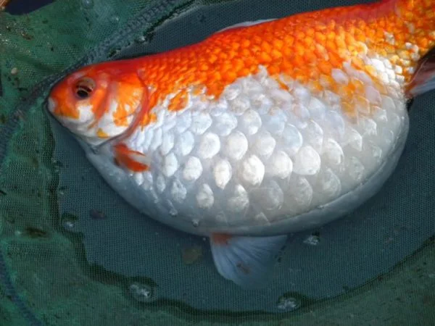
a. | Hemorrhage | c. | Exophthalmos
b. | Loss of pigmentation | d. | Dropsy

ANS: D PTS: 1

115. When observed under microscope gram positive bacteria looks like:
a. | Red or pinkish color | c. | Yellow color
b. | Purple color | d. | White color

ANS: B PTS: 1

116. Which of the following is the most significant limiting factor in the practice of aquaculture
a. | pH | c. | Salinity
b. | Dissolved Oxygen | d. | Nitrogen

ANS: B PTS: 1

117. What is the source of TAN?
a. | Air and Biomedia | c. | Plants
b. | Food | d. | Feces and Urine

ANS: D PTS: 1

118. At what level of unionized ammonia do your fish DIE
a. | 0.5 | c. | 2.0
b. | 1.0 | d. | 3.0

ANS: C PTS: 1

119. This is the end product of the nitrification process
a. | Nitrite | c. | Carbon Dioxide
b. | Nitrate | d. | Ammonium

ANS: B PTS: 1

120. What causes brown blood disease?
a. | Excessive Nitrates | c. | Excessive Heat
b. | Excessive Nitrites | d. | Excessive Ammonia

ANS: B PTS: 1

121. Why are high levels of CO2 harmful to fish?
a. | Increase of bacteria in water | c. | Feeding Increase
b. | Brown Blood Disease | d. | Suffocation

ANS: D PTS: 1

122. The ability to resist changes in pH
a. | Alkalinity | c. | Ammonification
b. | Hardness | d. | Nitrification

ANS: A PTS: 1

123. Besides Lime this common chemical easily impacts alkalinity
a. | Sugars | c. | Ammonia
b. | Sodium Thiosulfate | d. | Baking Soda

ANS: D PTS: 1

124. A pH above 7 is said to be
a. | Acidic | c. | Neutral
b. | Basic | d. | Poor for fish

ANS: B PTS: 1

125. What is the purpose of biomedia in a RAS system
a. | Break down non soluble waste | c. | Break down ammonia and nitrite
b. | Break down waste | d. | Fish Feeding

ANS: C PTS: 1

126. The waste from fish to feed the plants. What does the plants breakdown and use as food?
a. | Ammonia | c. | Nitrite
b. | Salt | d. | Nitrate

ANS: D PTS: 1

127. When the temperature is raised in the system you must plan to increase
a. | Lighting | c. | Water Flow
b. | Feedings | d. | Filtration

ANS: B PTS: 1

128. What kind of fish is this?
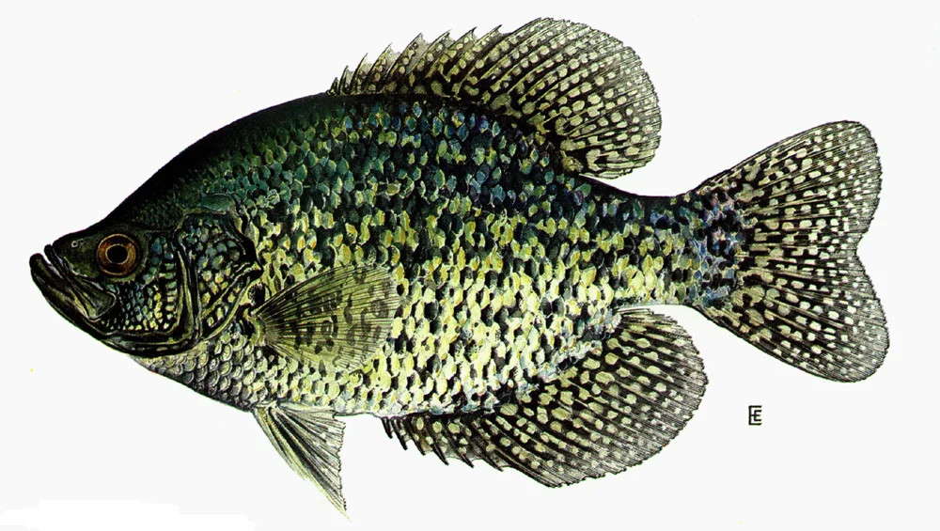
a. | Bluegill | c. | Black Crappie
b. | Spotted Crappie | d. | Smallmouth bass

ANS: C PTS: 1

129. What kind of fish is this?
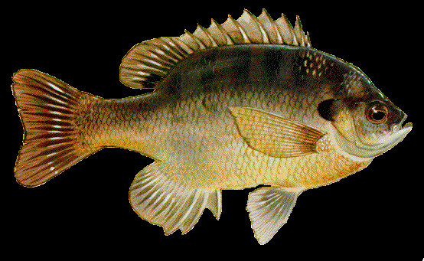
a. | Pumpkinseed | c. | Sunfish
b. | Bluefish | d. | Rock Bass

ANS: B PTS: 1

130. What kingdom are fish in?
a. | Animalia | c. | Aves
b. | Fishes | d. | Mammalia

ANS: A PTS: 1

131. What phylum are fish in?
a. | Mammalia | c. | Chordata
b. | Invertebrates | d. | Amphibians

ANS: C PTS: 1

132. Taking a net and dragging it across a pond
a. | Drag Net | c. | Skimmer net
b. | Seine | d. | Cast Net

ANS: B PTS: 1

133. On the average, how much feed is required to produce a pound of gain in fish?
a. | 0.5 lbs. | c. | 2.0 lbs.
b. | 1.0 lbs. | d. | 2.5 lbs.

ANS: C PTS: 1

134. List two ways oxygen gets into the water
a. | Diffusion and Osmosis | c. | Diffusion and Photosynthesis
b. | Diffusion and Respiration | d. | Photosynthesis and Osmosis

ANS: C PTS: 1

135. What is the name of this fish scale?
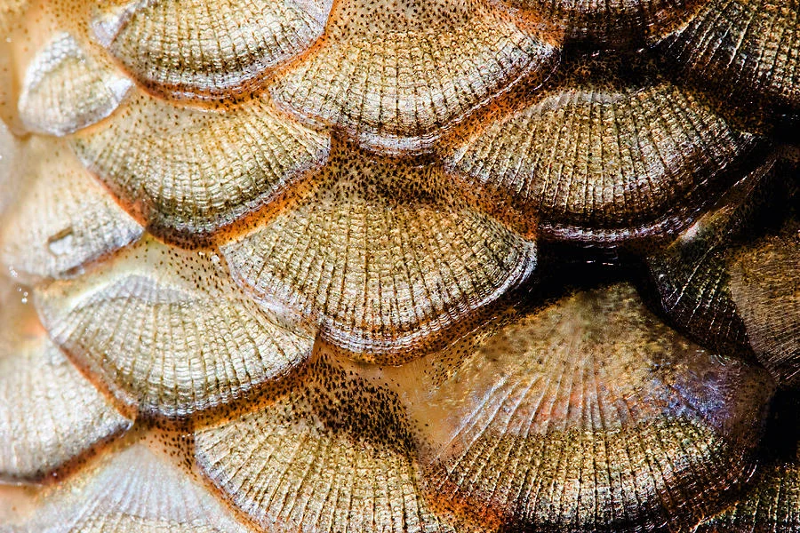

a. | Ganoid | c. | Placoid
b. | Cycloid | d. | Ctenoid

ANS: D PTS: 1

136. What is the name of this fish scale?
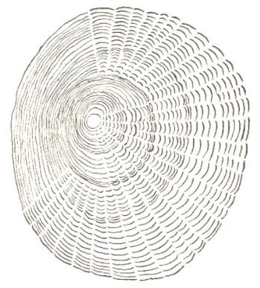

a. | Placoid | c. | Placoid
b. | Cycloid | d. | Ctenoid

ANS: B PTS: 1

137. What is the shape of this caudal fin?
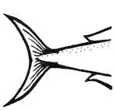
a. | Forked | c. | Lunate
b. | Rounded | d. | Emarginate

ANS: C PTS: 1

138. What is the shape of this caudal fin?
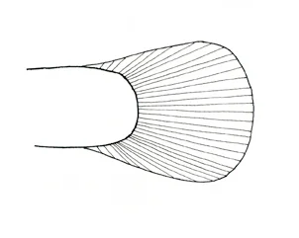
a. | Forked | c. | Lunate
b. | Rounded | d. | Emarginate

ANS: B PTS: 1

139. What is the name of this fish scale?
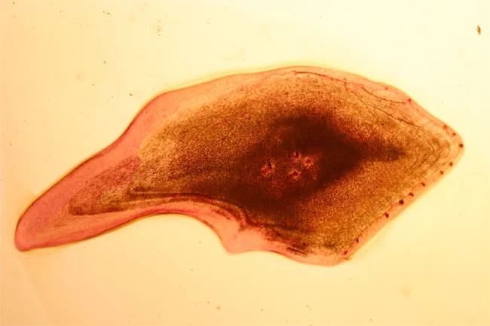

a. | Ganoid | c. | Placoid
b. | Cycloid | d. | Ctenoid

ANS: A PTS: 1

140. What is the shape of this caudal fin?
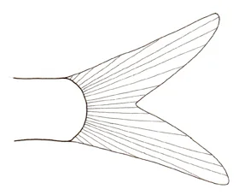
a. | Forked | c. | Lunate
b. | Rounded | d. | Emarginate

ANS: A PTS: 1

141. Most fish are covered with _____, which are thin, bony plates that provide protection
a. | Skin | c. | Slime
b. | Scales | d. | Barbels

ANS: B PTS: 1

142. Located on the ventral surface behind the anus, and used for stabilizing for swimming
a. | Dorsal fin | c. | Dorsal fin
b. | Anal fin | d. | Caudal fin

ANS: B PTS: 1

143. Another name for operculum is
a. | Gill Cover | c. | Lateral Line
b. | Gonadipodium | d. | Gill filaments

ANS: A PTS: 1

144. A fish that has an upturn mouth will feed at the
a. | Bottom | c. | Mid
b. | Top | d. | All over

ANS: B PTS: 1

145. Torpedo like shape that allows a fish to be a swift swimmer
a. | round | c. | square
b. | oblong | d. | fusiform

ANS: D PTS: 1

146. Term used to describe reproduction when eggs are laid outside the female’s body.
a. | placental | c. | ovoviviparous
b. | viviparous | d. | oviparous

ANS: D PTS: 1

147. In the life cycle of a fish when a male fish changes to a female
a. | protogyny | c. | protandry
b. | spawning | d. | morphology

ANS: C PTS: 1

148. Pigment cells in the skin of a fish
a. | epidermis | c. | cycloid
b. | placoid | d. | chromatophores

ANS: D PTS: 1

149. Tool used in identification and classification, that uses paired statements to ID organisms
a. | taxonomy | c. | morphology
b. | dichotomous key | d. | diffusion

ANS: B PTS: 1

150. Ability to float or sink is referred to as_________
a. | regulator | c. | buoyancy
b. | density | d. | swim bladder

ANS: C PTS: 1

151. Protective covering on the eye of a shark
a. | nictitating membrane | c. | lateral line
b. | Ampullae of Lorenzini | d. | dermal denticle

ANS: A PTS: 1

152. Structures that look like whiskers that aid catfish in finding food
a. | dermal denticles | c. | cartilage
b. | spiracles | d. | barbels

ANS: D PTS: 1

153. Type of reproduction when females bear live young with a placenta
a. | viviparous | c. | oviparous
b. | ovoviviparous | d. | spiracle

ANS: A PTS: 1

154. Type of reproduction involving internal young attached to yolk sacs
a. | oviparous | c. | ovoviviparous
b. | viviparous | d. | placental

ANS: C PTS: 1

155. Movement of dissolved oxygen from the water into the blood at the gills of a fish
a. | absorption | c. | transport
b. | diffusion | d. | osmosis

ANS: B PTS: 1

156. When females swim upstream to lay eggs and males follow to fertilize them
a. | buoyancy | c. | spawning
b. | protogyny | d. | breeding

ANS: C PTS: 1

157. Saltwater (marine) ecosystems make up ______ of all water on earth.
a. | 3% | c. | 97%
b. | 50% | d. | 100%

ANS: C PTS: 1

158. Freshwater ecosystems make up _____ of all water on Earth.
a. | 3% | c. | 97%
b. | 50% | d. | 100%

ANS: A PTS: 1

159. Most of earth's freshwater is in _______.
a. | gulfs, seas, and oceans | c. | lakes, rivers, and seas
b. | ponds, seas, and bays | d. | glaciers, lakes, and rivers

ANS: D PTS: 1

160. What is aquaculture?
a. | The study of saltwater and freshwater organisms for use in medicine
b. | The breeding of land plants and animals to be used as fish feed
c. | The manufacturing of aquatic organisms into feed and fertilizer
d. | The breeding, raising and harvesting of both fresh and saltwater organisms

ANS: D PTS: 1

161. Fresh and saltwater mix in
a. | rivers | c. | streams
b. | lakes | d. | brackish water

ANS: D PTS: 1

162. What is a production facility that recycles water?
a. | tank | c. | recirculating facility
b. | offshore aquaculture | d. | raceway

ANS: C PTS: 1

163. Which of these types of fish is NOT good for aquaponics?
a. | tilapia | c. | koi
b. | clownfish | d. | bluegill

ANS: B PTS: 1

164. In what year, did the Chinese start raising carp which started the aquaculture industry?
a. | 1100 BC | c. | 600 BC
b. | 1650 | d. | 2018

ANS: A PTS: 1

165. What is the number one state of freshwater diversity
a. | California | c. | Minnesota
b. | Texas | d. | Alabama

ANS: D PTS: 1

166. What is the name of this fish scale?
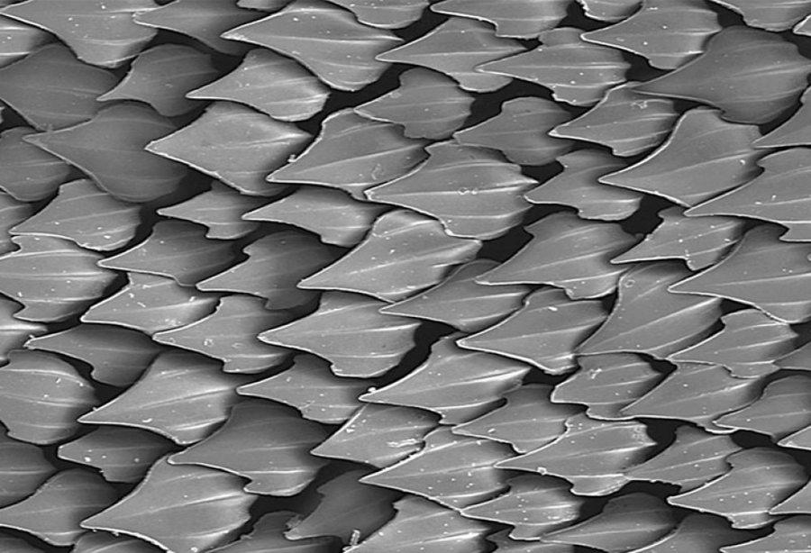

a. | Ganoid | c. | Placoid
b. | Cycloid | d. | Ctenoid

ANS: C PTS: 1

167. Cartilaginous fishes that have long, eel-like bodies, no scales, no appendages, and no jaws
a. | Superclass Agnatha | c. | Class Osteichthyes
b. | Class Chondrichthyes | d. | Superclass Gnathostomata

ANS: A PTS: 1

168. Jawless fish that have a circular mouth that is continuously open; many are parasitic; some migrate to freshwater to reproduce
a. | hagfish | c. | lampreys
b. | guitarfish | d. | sunfish

ANS: C PTS: 1

169. Cartilaginous fishes that include sharks, skates, and rays
a. | Superclass Agnatha | c. | Class Osteichthyes
b. | Class Chondrichthyes | d. | Superclass Gnathostomata

ANS: B PTS: 1

170. What is one way to lower the amount of nitrates in your tank?
a. | do a partial water change | c. | add more fish
b. | remove fish | d. | lower the water temperature

ANS: A PTS: 1

171. Which species is the top producer in the US?
a. | Catfish | c. | Striped Bass
b. | Tuna | d. | Salmon

ANS: A PTS: 1

172. How much of the world's seafood comes from aquaculture?
a. | 75% | c. | 50%
b. | 25% | d. | 10%

ANS: C PTS: 1

173. What type of tail fin allows fish to swim slow?
a. | forked | c. | lunate
b. | rounded | d. | emarginate

ANS: B PTS: 1

174. When dissolved Nitrite in the water is abnormally high, the condition it causes in fish is?
a. | high gas | c. | gas bubble disease
b. | bubbles | d. | brown blood disease

ANS: D PTS: 1

175. A sample of water that contains 180 ppm of Calcium Carbonate. This water would be considered...
a. | soft | c. | very hard
b. | hard | d. | moderately soft

ANS: B PTS: 1

176. Respiration by fish adds CO2 to the water. This ___ pH of the water
a. | increases | c. | decreases
b. | neutralizes | d. | does not change the pH

ANS: C PTS: 1

177. The salinity of seawater is ...
a. | 5 ppt | c. | 15 ppt
b. | 35 ppt | d. | 60 ppt

ANS: B PTS: 1

178. In catfish, broken back disease is caused by ...
a. | vitamin deficiency | c. | protein deficiency
b. | bacterial blood disease | d. | parasitic infection

ANS: A PTS: 1

179. What causes Ich?
a. | Bacteria | c. | Nutrition issue
b. | Virus | d. | Parasite

ANS: D PTS: 1

180. Feeding behavior is easier to monitor when _____ feed is used.
a. | floating | c. | sinking
b. | meal | d. | live

ANS: A PTS: 1

181. What does a 1.5 feed conversion ration mean?
a. | fish produce 1.5 lbs. of fish per pound of feed
b. | Fish must be fed 1.5 lbs. before converted
c. | fish must weigh 1.5 lbs. before they can convert the feed
d. | fish produce 1.5 lbs. of body weight per 1.5 lbs. per feed

ANS: D PTS: 1

182. What is the normal weight at which shrimp are harvested in the United States?
a. | 16-18 grams | c. | 5-7 grams
b. | 10-15 grams | d. | 20 grams

ANS: A PTS: 1

183. The hybrid Striped Bass is a cross between which two fish?
a. | Hybrid Carp and White Bass | c. | White Bass and hybrid trout
b. | White Bass and hybrid trout | d. | Striped Mullet and Striped Bass

ANS: C PTS: 1

184. Most commonly cultured trout is ___?
a. | lake | c. | brown
b. | brook | d. | rainbow

ANS: D PTS: 1

185. Which type of breeding improves growth rate, feed conversion, and disease resistance?
a. | inbreeding | c. | pure breeding
b. | crossbreeding | d. | homozygous cross

ANS: B PTS: 1

186. Under ideal conditions, how often can female tilapia spawn
a. | once a year | c. | every 4-6 weeks
b. | twice a year | d. | every 6-10 weeks

ANS: C PTS: 1

187. 10 ppm = 10 parts salt _________ parts water
a. | 1,000,000,000 | c. | 1,000
b. | 1,000,000 | d. | 100,000

ANS: B PTS: 1

188. What does ectothermic mean?
a. | warm blooded | c. | warm extremities
b. | cold blooded | d. | cold extremities

ANS: B PTS: 1

189. Located on the ventral side of the fish in front of the anal fin, and helps balance the fish, keep it level, and prevent it from rolling side to side.
a. | dorsal fin | c. | caudal fin
b. | pelvic fin | d. | anal fin

ANS: B PTS: 1

190. Located on the ventral side of the fish near the gills and helps steer and control the depth of a fish.
a. | dorsal fin | c. | caudal fin
b. | pelvic fin | d. | pectoral fin

ANS: D PTS: 1

191. Located on the posterior end of the fish and provides power for swimming and assisting in steering.
a. | dorsal fin | c. | caudal fin
b. | pelvic fin | d. | pectoral fin

ANS: C PTS: 1

192. Located on the top of the fish along the back between the head and tail, aids in turning and keeps the fish upright.
a. | dorsal fin | c. | caudal fin
b. | pelvic fin | d. | pectoral fin

ANS: A PTS: 1

193. Finger-like projections located in the stomach of the fish that secretes digestive enzymes to increase surface area and nutrient absorption.
a. | Fish digestive chamber | c. | Intestinal extension
b. | Enzyme producing organ | d. | Pyloric caecum

ANS: D PTS: 1

194. What is the primary function of gill rakers in fish?
a. | Temperature regulation | c. | Carbon dioxide release
b. | Oxygen diffusion | d. | Water filtration

ANS: B PTS: 1

195. What does RAS mean?
a. | Regenerative Aquatic System | c. | Recirculating Aquaculture System
b. | Rapid Aeration System | d. | Reservoir Algae Scrubber

ANS: C PTS: 1

196. What are the 4 products of aquaculture
a. | Food, Recreational, Ornamental and Medicinal | c. | Ornamental, Mariculture, Food and Bait
b. | Shelter, Sustainability, Food and Bait | d. | Recreational, Environmental, Medicinal, and Food

ANS: A PTS: 1

197. What does polyculture refer to in aquaculture?
a. | Raising different fish species together in a shared aquatic environment | c. | Breeding multiple fish varieties in separate tanks
b. | Managing a singular species in a controlled aquatic setting | d. | Extracting fish from natural water bodies

ANS: A PTS: 1

198. Which agency regulates fish food in the U.S
a. | FDA | c. | EPA
b. | FWW | d. | NSF

ANS: A PTS: 1

199. Aquaculture systems that are located within a lake, river, or ocean are called what?
a. | Polyculture | c. | Olericulture
b. | Fresh culture | d. | Mariculture

ANS: D PTS: 1

200. Approximately what percentage of seafood consumed/eaten today was grown through aquaculture
a. | 10% | c. | 30%
b. | 15% | d. | 50%

ANS: D PTS: 1

201. Cage aquaculture in a lake is an example of what type of system?
a. | Closed | c. | Recirculating
b. | Open | d. | Intensive

ANS: B PTS: 1

202. How do aquatic plants produce food/energy?
a. | Ammonia conversion | c. | pH absorption
b. | Consuming plankton | d. | Photosynthesis

ANS: D PTS: 1

203. Where does Alabama rank nationally in catfish production?
a. | 2nd | c. | 1st
b. | 5th | d. | 9th

ANS: A PTS: 1

204. What does carrying capacity refer to in an ecosystem?
a. | The maximum number of species present in an ecosystem | c. | The number of predators in an ecosystem
b. | The ability of an ecosystem to support a particular population size sustainably | d. | The rate of growth of a population in an ecosystem

ANS: B PTS: 1

205. Which state leads the nation in catfish production?
a. | Alabama | c. | Mississippi
b. | Arkansas | d. | Louisiana

ANS: C PTS: 1

206. Which of the following is the best natural soil type for lining the bottom of a fishpond?
a. | Silt | c. | Sand
b. | Loam | d. | Clay

ANS: D PTS: 1

