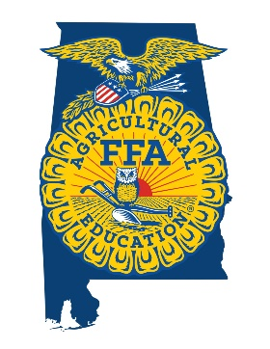
Alabama FFA Association
State Convention Talent Showcase

Name(if group, include all participants): _____________________________________________
_____________________________________________
_____________________________________________
FFA Chapter: ______________________________ Advisor: _____________________________
School Address: ________________________________________________________________
________________________________________________________________
Advisor Phone Number: __________________________________________________________

Talent Act Description: Please provide specific details as to the nature of the act (individual, duo, singer, instrumentalist, band, dancer, comedic, etc.) as well as any props or instruments involved.
______________________________________________________________________________________________________________________________________________________________________________________________________________________________________________________________________________________________________________________________________________________________________________________________________

Equipment Needs Request: Please list any equipment that you will need to have provided for
your performance.
________________________________________________________________________________________________________________________________________________________________________________________________________________________________________________________________________________________________________________________

Audition Link: Please upload a video sampling of your talent (no more than 6 minutes) to YouTube and provide the link below. You can make this an unlisted video if you wish for it to not be published to the public.
______________________________________________________________________________

*If selected, all acts will receive follow up information with further requests and waivers. All selected participants will be required to complete the waiver located in this document if selected. A detailed schedule of performances will be provided prior to convention.

Advisor Signature: __________________________________ Date: _________________

State Talent Showcase Performance List

When completing this form:
- If a musical act, list up to six songs you plan to perform during convention. Also, please submit lyrics for each song selected.
- For other acts that will utilize music, please list all musical selections as well as any lyrics to those songs.
- If a comedic act, please submit a transcript of your act including all jokes and material presented.

Name of Act and FFA Chapter: _____________________________________________________

 | Song | Artist | Length | Does this song have lyrics or is it just instrumental?
1
2
3
4
5
6

Act Equipment Requests:
* We cannot guarantee all equipment requests will be fulfilled. This will be communicated prior to convention.

* Please attach all lyrics, manuscripts, or other content to this document.

