Aquaculture / Aquaponics 101 Teacher Workshop
July 10-14, 2023 – Auburn, Alabama

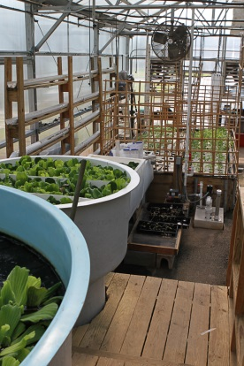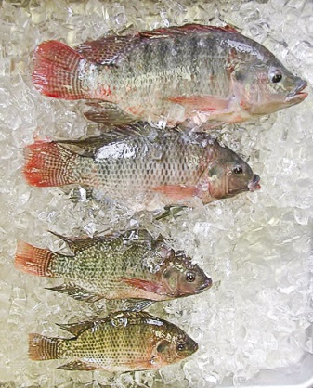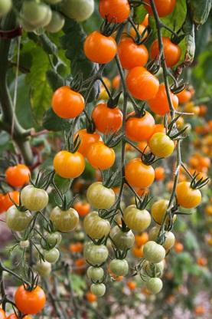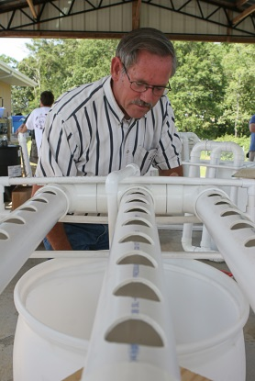
Aquaponics is being utilized in classrooms across the country to excite and engage students and teachers. Aquaponics is the art/science of growing fish and plants in a symbiotic relationship in a single system. It is a combination of aquaculture and hydroponics. The fish are fed a high quality prepared diet and their waste is used as fertilizer to grow plants. The plants in turn act as a filter to clean the water that can be returned to the fish tank. There is tremendous interest in Aquaponics and aquaculture as a platform to teach real world applications of biology, chemistry, math and science. Working with an aquaponics system also requires technical skills in plumbing, carpentry and sometimes masonry. It is an excellent tool to examine the different elements of business management and marketing.
The trouble is that most teachers don’t have any training in aquaponics. The Aquaculture/Aquaponics 101 Workshop provides hands-on training and expert advice on how to start and operate an aquaponics system and provides resource materials to help integrate the knowledge into existing curriculum. Teachers will design and build a complete aquaponics system that they can take back to their school. Faculty from Auburn University, the Alabama Cooperative Extension System and the Alabama, Mississippi Sea Grant Consortium provides expert instruction.
The workshop will be held at the E.W. Shell Fisheries Center, 2101 N. Collage St. July 10-14, 2023 in Auburn, Alabama. The cost for the workshop is $295 and 32 hours of continuing education credit is available.
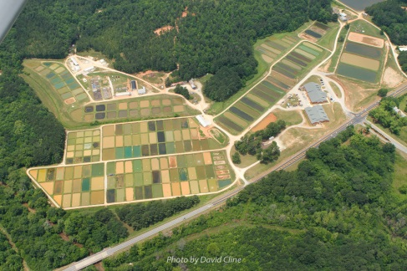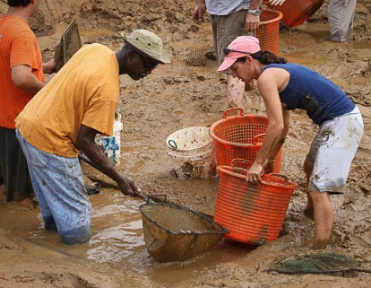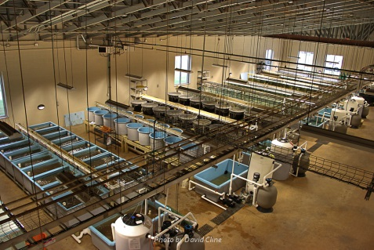
The AU Fisheries and Aquaculture program world renowned for its teaching, research and Extension efforts. The facility is the largest of its kind in the world with over 1800 acres, 350 ponds, and nearly 2,000 aquaria.
For more information contact David Cline 334-844-2874 or PJ Waters 251-438-5690
Photos from the 2019 Aquaponics 101 Teacher reactions to the workshop
Aquaponics 101 Teacher Training Workshop
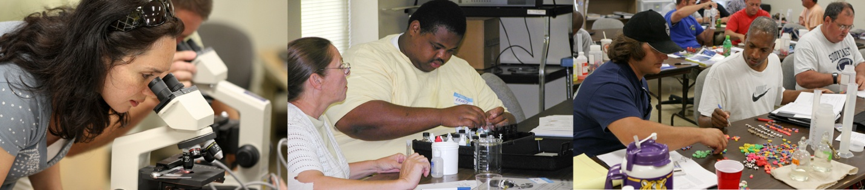
When: July 10-14, 2023 8:00am to 4:30 pm daily (8-12 on Friday)

Where: (Physical) (Mailing)
Auburn University 203 Swingle Hall
E.W. Shell Fisheries Center Auburn University, AL 36849
2101 North College St.
Auburn, AL 36830

Cost: $295 to attend the workshop
This includes resources that previous teachers felt were worth $400+
(Travel and living expenses not included)

CEUs: 32 hours of continuing education credits

Capacity: Due to the hands-on nature of the workshop, seating is limited to 30 participants Please Register Online
Or Call David Cline 334-844-2874 / 334-744-2688

Information: David Cline (AU) 334-844-2874 - clinedj@auburn.edu
P.J. Waters (AU-Sea Grant) 251-438-5690 - Waterph@auburn.edu
Stan Arington (AU Fisheries Learning Center) 334-844-4630 sca0028@auburn.edu

Topics Addressed Include
Biology | Chemistry | Math
Aquaponics – Integrating plant and fish culture | Nitrogen cycle – ammonia, nitrite, nitrate | Nutrient input vs. grow bed capacity
Catfish and tilapia morphology | Dissolved oxygen | Volumetric displacement
Fish culture techniques | Alkalinity | Feeding rates
Pond dynamics | PH | Feed conversion and growth rate
Diseases of warm water fish | Hardness | Tank and system volumes
Fish hatchery operations | Temperature effects | Surface area of biofilter material
Components and functions of a recirculating aquaculture system | Water quality relationships | How to correctly size a biofilter
Fish genetics (super male tilapia) | And Many Other Topics | Average weights
Aquaponics 101 - Registration Form
Teacher Workshop July 10-14, 2023
Seating limited to first 30 people

Register Online at: HERE Or https://www.aces.edu/go/Aquaponics101
If you mail in your registration and payment, be sure to notify and/or email a copy to clinedj@auburn.edu so we can be on the lookout for it.

Mail this form with your $295 check to : David Cline
Payable to Auburn University 203 Swingle Hall
Auburn University, AL 36849

Name: ____________________________________________________________
Home Address: _____________________________________________________
__________________________________________________________________
Home phone: ______________________________________________________
School: ___________________________________________________________
School address: _____________________________________________________
__________________________________________________________________
School phone: ______________________________________________________
E-mail address: _____________________________________________________
Grades taught: ______________________________________________________
Courses taught: _____________________________________________________
__________________________________________________________________
Briefly describe the current aquaculture facilities available at your school. ______ __________________________________________________________________
__________________________________________________________________
__________________________________________________________________
If you have questions contact David Cline 334-844-2874, 334-744-2688 cell
Technical Info: David Cline, 334-844-2874 (AU, ACES) - clinedj@auburn.edu
PJ Waters, 251-438-5690 (Sea Grant, ACES, AU) Waterph@auburn.edu
Stan Arington (Fisheries Learning Center) 334-844-4630 sca0028@auburn.edu

Workshop sponsored by Alabama Cooperative Extension System, Auburn University School of Fisheries, Aquaculture and Aquatic Sciences, Auburn Marine Extension and Research Center and the Mississippi-Alabama Sea Grant Consortium.

