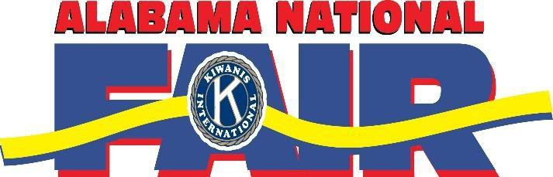2020

**2021 Alabama Dairy Quiz Bowl**



**Dairy Quiz Bowl: Sunday, October 13**

4:00 pm – Sign In

4:15 pm – Dairy Quiz Bowl Contest

**Dairy Judging Contest – Monday, October 14**

7:30 am – 8:00 am – Sign In

8:30 am – Dairy Judging Contest begins

DEADLINE: FRIDAY, SEPTEMBER 17TH AT 5PM

These contests will be held during the Alabama National Fair in the Teague Arena (Garrett Coliseum).

1555 Federal Drive

Montgomery, AL 36107

**QUIZ BOWL (4-H: SR. & JR. ONLY) AND JUDGING (FFA & 4-H: SR. & JR.)**

To register you must send in your team’s information or individual’s information via email before 5:00 pm on Friday, September 17th to [bradybo@auburn.edu.](mailto:bradybo@auburn.edu) Information needed includes:

* School Name (FFA) or County Name (4-H)
* Advisor or Extension Agent Name(s)
* Names of team members (be sure the number of names you have listed matches the number of people you are bringing.) If 4-H must have a 4-H on-line membership number.
* Teams may consist of a maximum of **4 Members** and **2 Alternates**.
* Contest or contest being registered for (whether 4-H and/or FFA Judging or 4-H JR. or SR. Quiz Bowl)
* Entry tickets needed (*explanation on following page)
* Parking Passes needed (*explanation on following page)

When you have sent in your registration form, we will send a confirmation e-mail in return. Please allow up to 5 days for a confirmation e-mail. If you have not received a confirmation within 5 days, please contact Boyd Brady or Brooke Zeleny at (334) 844 – 1562 or [bradybo@auburn.edu.](mailto:bradybo@auburn.edu) Bring the e-mail confirmation with you on the day of the contest(s) in which you have registered.



TO PARTICIPATE IN ANY 4-H CONTEST, THE PARTICIPANT MUST BE SIGNED UP AS A 4-H

MEMBER ON-LINE. THE NEW 4-H CLUB YEAR STARTS ON AUGUST 1ST SO 4-H MEMBERS HAVE UNTIL AUGUST 15, 2020 TO RENEW THEIR MEMBERSHIP OR BECOME A NEW MEMBERS. TO SIGN UP AS A 4-H MEMBER, USE 4HONLINE OR GO TO YOUR LOCAL EXTENSION OFFICE AND ASK FOR ASSISTANCE.

*You must also sign up for the event (Dairy Judging and/or Dairy Quiz Bowl) before September 17, 2020.



* Per Team for one contest (Quiz Bowl OR Judging) is $20.00
* Per Team for both contests (Quiz Bowl AND Judging) is $32.00
* Individual for **Judging** contest is $5.00



* Buses will not be charged to park.
* Personal vehicles (includes vans) will be $5.00 per vehicle.



Entry tickets will be required! All tickets will be pre-ordered at a discount rate. Pre-paid entry tickets will be $5.00 on or before Friday, September 17th. After this date, the tickets pricings will vary based on Fair’s daily gate admission price. Please be sure to double check you have ordered enough tickets for participates. These tickets can be used for team members, advisors, and chaperones only.

Payments for pre-paid tickets will be sent to Stephanie Pittman, Alabama National Fair. Additional or late tickets may be purchased taken upon arrival to the Fair at the Livestock Gate. The Fair management will have envelopes with advisors’ names and the number of pre-paid tickets at the gate waiting upon your arrival.

Please make all checks payable to the “Alabama National Fair” – All payments are due by Monday, September 20.

**\*\*\* The registration, parking, or entry ticket fee DOES NOT include food costs. Individuals or teams will be responsible for their own food and drink. \*\*\***

CONTACT INFORMATION

BOYD BRADY AND BROOKE ZELENY OFFICE (334) 844 – 1562

CELL (334) 321 – 8826 [BRADYBO@AUBURN.EDU](mailto:BRADYBO@AUBURN.EDU)

STEPHANIE PITTMAN OFFICE (334) 272-6831

DIRECT (334) 356-4739 [STEPHANIE@ALNATIONALFAIR.ORG](mailto:STEPHANIE@ALNATIONALFAIR.ORG)

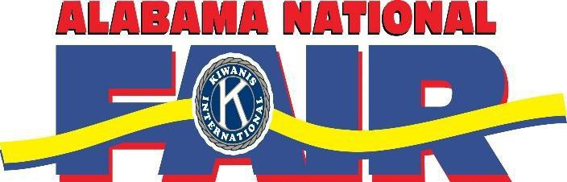

**2021 Alabama Dairy Quiz Bowl**





DEADLINE: FRIDAY, SEPTEMBER 17TH AT 5PM

**\*SEND THIS FORM & ALL PAYMENTS TO STEPHANIE PITTMAN, LOCATED IN THE ALABAMA FAIR OFFICE**

|  |  |  |
| --- | --- | --- |
| **Quiz Bowl (4-H Only): Circle One**  **SENIOR DIVISION JUNIOR DIVISION** | **Judging Contest (FFA & 4-H):**  **Circle One SENIOR DIVISION JUNIOR DIVISION** | **INDIVIDUAL**  **Judging Contest (FFA & 4-H): Circle One**  **SENIOR DIVISION/ JUNIOR DIVISION** |

School Name (FFA):

County Name (4-H):

Advisor/ Extension Agent Name:

|  |  |  |
| --- | --- | --- |
| TEAM MEMBER NAME | TICKET NEEDED  (Only if they have not entered a livestock show.) | 4-H Membership # |
| 1. |  |  |
| 2. |  |  |
| 3. |  |  |
| 4. |  |  |
| ALTERNATE MEMBERS |  |  |
| 5. |  |  |
| 6. |  |  |

Quiz Bowl Entry Fee: ($20.00 per Team)

Please make as many copies as needed.

Individual Judging Fee: ($5.00 per Person)

Judging Team Entry Fee: ($20.00 per Team)

This form must be faxed or emailed to Stephanie Pittman NO later than September 17th at 5 PM.

Fax: (334) 272 - 6835

Email: [Stephanie@alnationfair.org](mailto:Stephanie@alnationfair.org)

Entry Tickets ($5.00 each):

Parking ($5.00 each):

TOTAL: