Setting up your SAE in the Agriculture Experience Tracker
- Go to the AET (Agriculture Experience Tracker) website. www.theaet.com / or Google search it.
Below is what the website will look like.
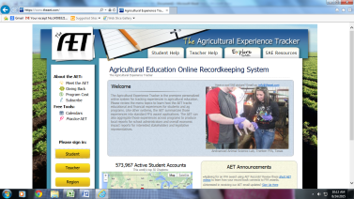
- Click on Student on the left-hand side of the screen.
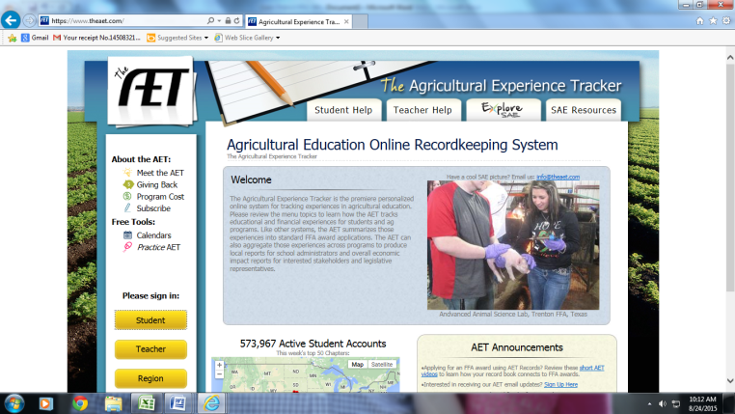

- When the screen comes up, you will enter your information.
Chapter Number: AL0079
User Name: Your first name initial capitalized with your last name and the first letter capitalized for example my username would be JDyess.
Password: This will be the same thing as your username until you change it.
Click continue once you have entered your information.

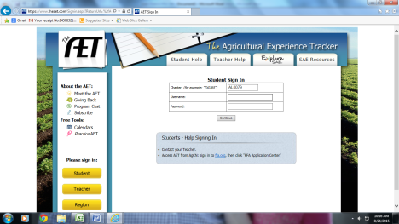

- The screen that comes up will be your Dashboard (Home Screen).
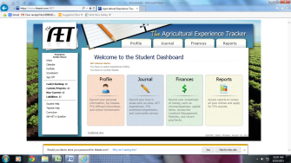

- Click on Profile. Under about you click on click on manage/edit your profile.
  - You many change your password here. (Please make sure it is something you can remember!!!!)
  - Update your demographic information. (Address, phone, etc.)
  - You can also set up an email address, so you can email pictures to your account from your phone.
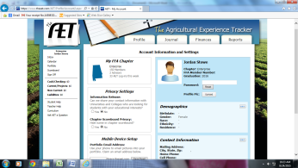

- Click on Profile to go back to your profile page. Then click on record your ag class schedule. Then click on add class. Choose the class/es you are in now, and click add.
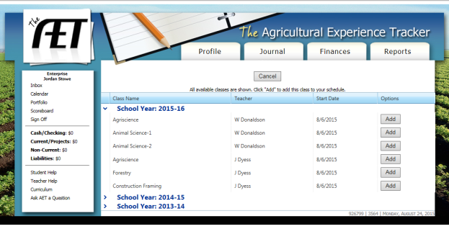

*If you have been in classes in previous years you can click on that school year and add that class as well.

- Click on profile to go back to your profile page. Then under activities, click on experience manager. Click add new. Then fill in the information with your SAE information, and click save. Below is an example of a student’s SAE information filled in.
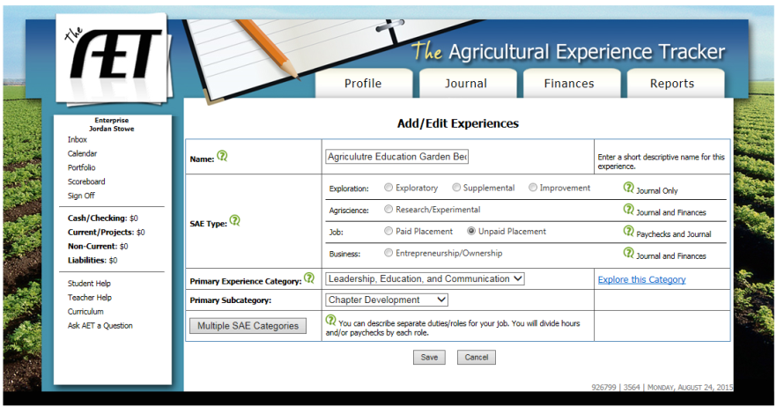

*If you are going to have more than 1 SAE go ahead and add that one as well.
8. Once you have saved your SAE you will then come to a screen that has it listed with a few icons to the left of it. You are going to click on the pencil, which will take you to your plan.
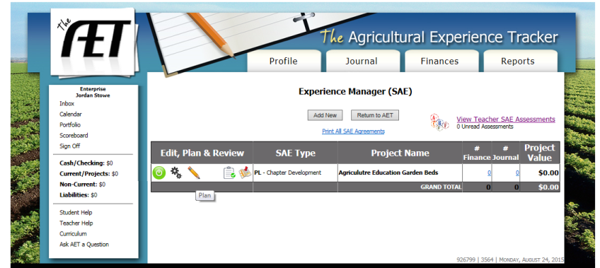
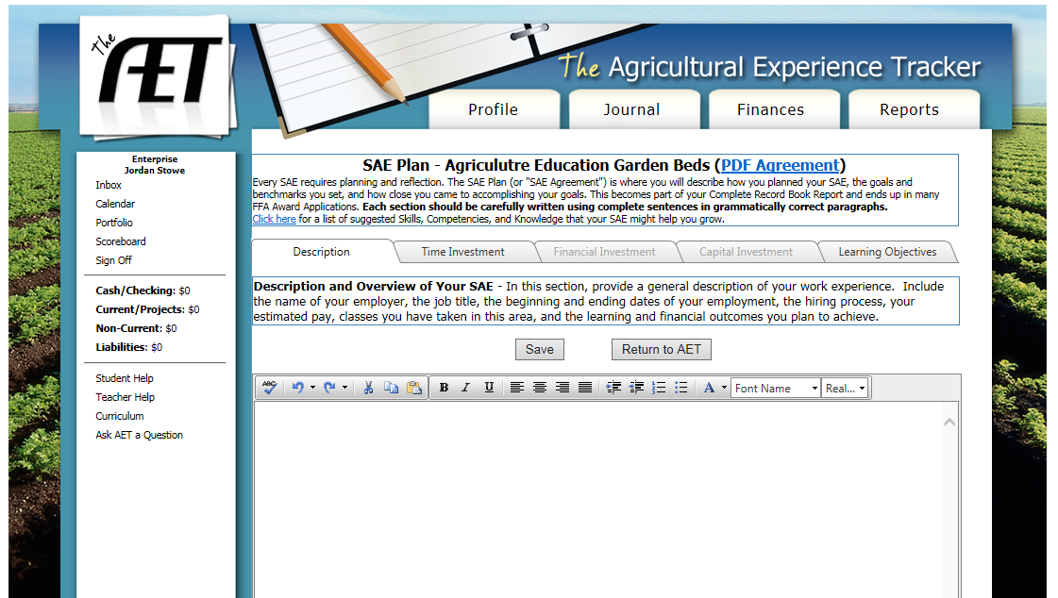
*This is where you will toggle through the tabs and will report the plan for your SAE. These plans have to be in complete sentences and in paragraph form. Be sure to completely answer the question that is being asked. There are several explanations on the page that you can use to help you.
*There are 5 tabbed categories at the top; you are to fill out each one that is highlighted. If it is not allowing you to click on it that means it does not apply to your SAE.
*Be sure to save your work!

****On the left-hand side of the screen, there is a button that will says student help. That will assist you if you have any questions.

