AET Journal Entries for Your SAE
- Log into your AET account.
- On your dashboard click Journal.
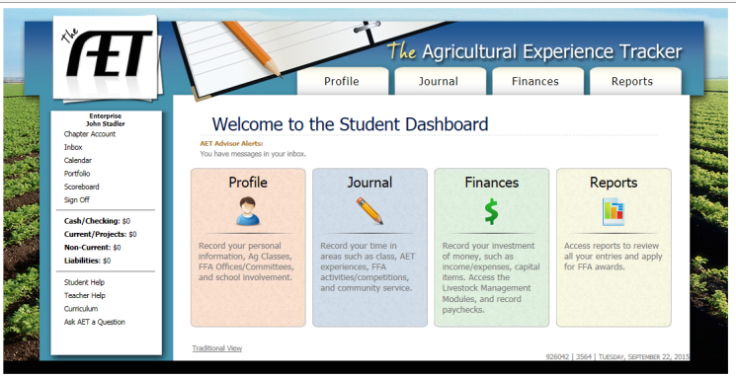
CLICK!

- Then click on the “Time in your AET Experience.”
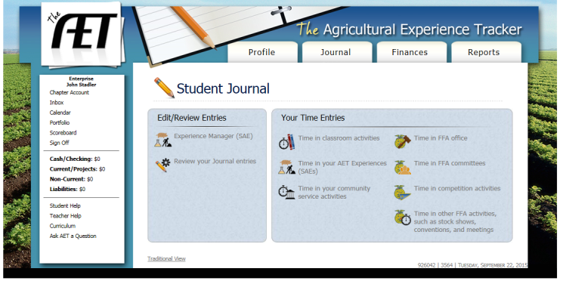
CLICK!

- Fill out the information about the time you spent that day working on your SAE.
  - Date
  - Activity
  - Amount of hours/ minutes
  - Description of activity. This MUST be in complete sentences, and detailed!
  - You can upload a picture(s) if you wish. (Remember you HAVE to have 4 pictures for every 8 hours!!!)
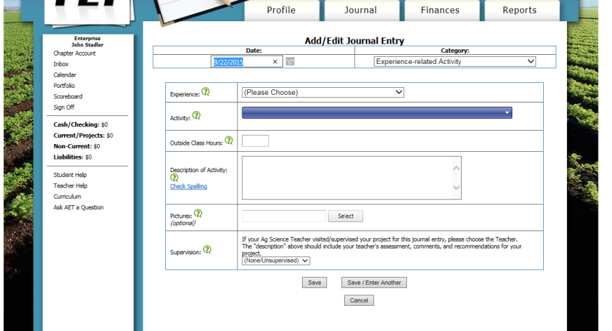
Choose your picture(s) if you would like. I do not recommend uploading pictures here.
Description of what you did. Complete Sentences!!!!!!!
DETAILS!
Amount of time
Experience-Choose the best one
DATE

- Click save.
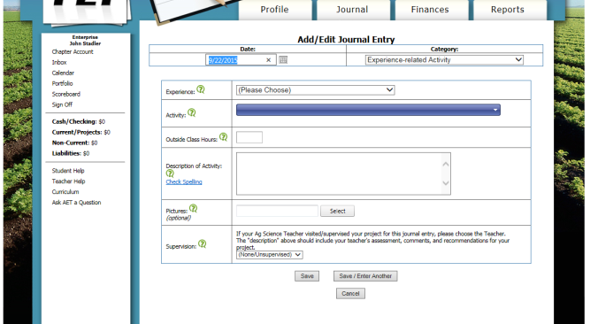
CLICK!

- To see all of your journal entries you can click on “Review your journal entries” under the Journal tab. This will allow you to see all of your work. (Remember each due date you must have at least 6 hours of work!)
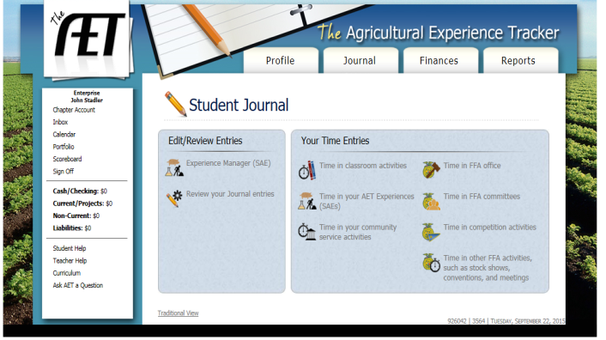
CLICK!
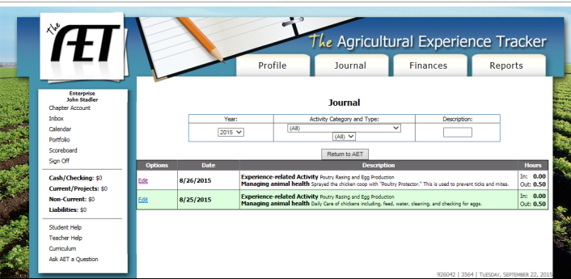

- To view the pictures you have uploaded, click on “Portfolio” in the left-hand box. This is where I would upload pictures.
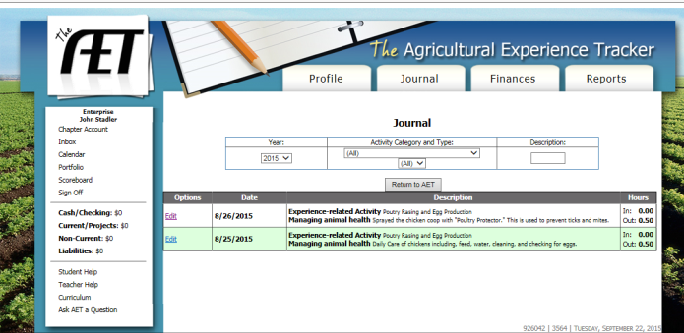
If you do not see your pictures here in the portfolio, then they did not upload properly. If you can’t see them then I can’t either when I grade,
CLICK!

- Then click on the “Experience” drop down box, choose your experience and your pictures should be in the portfolio.
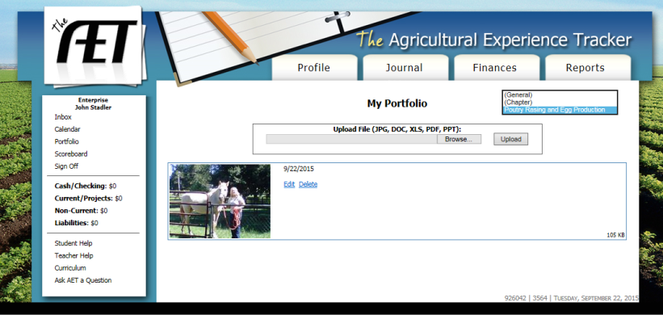
CLICK!

