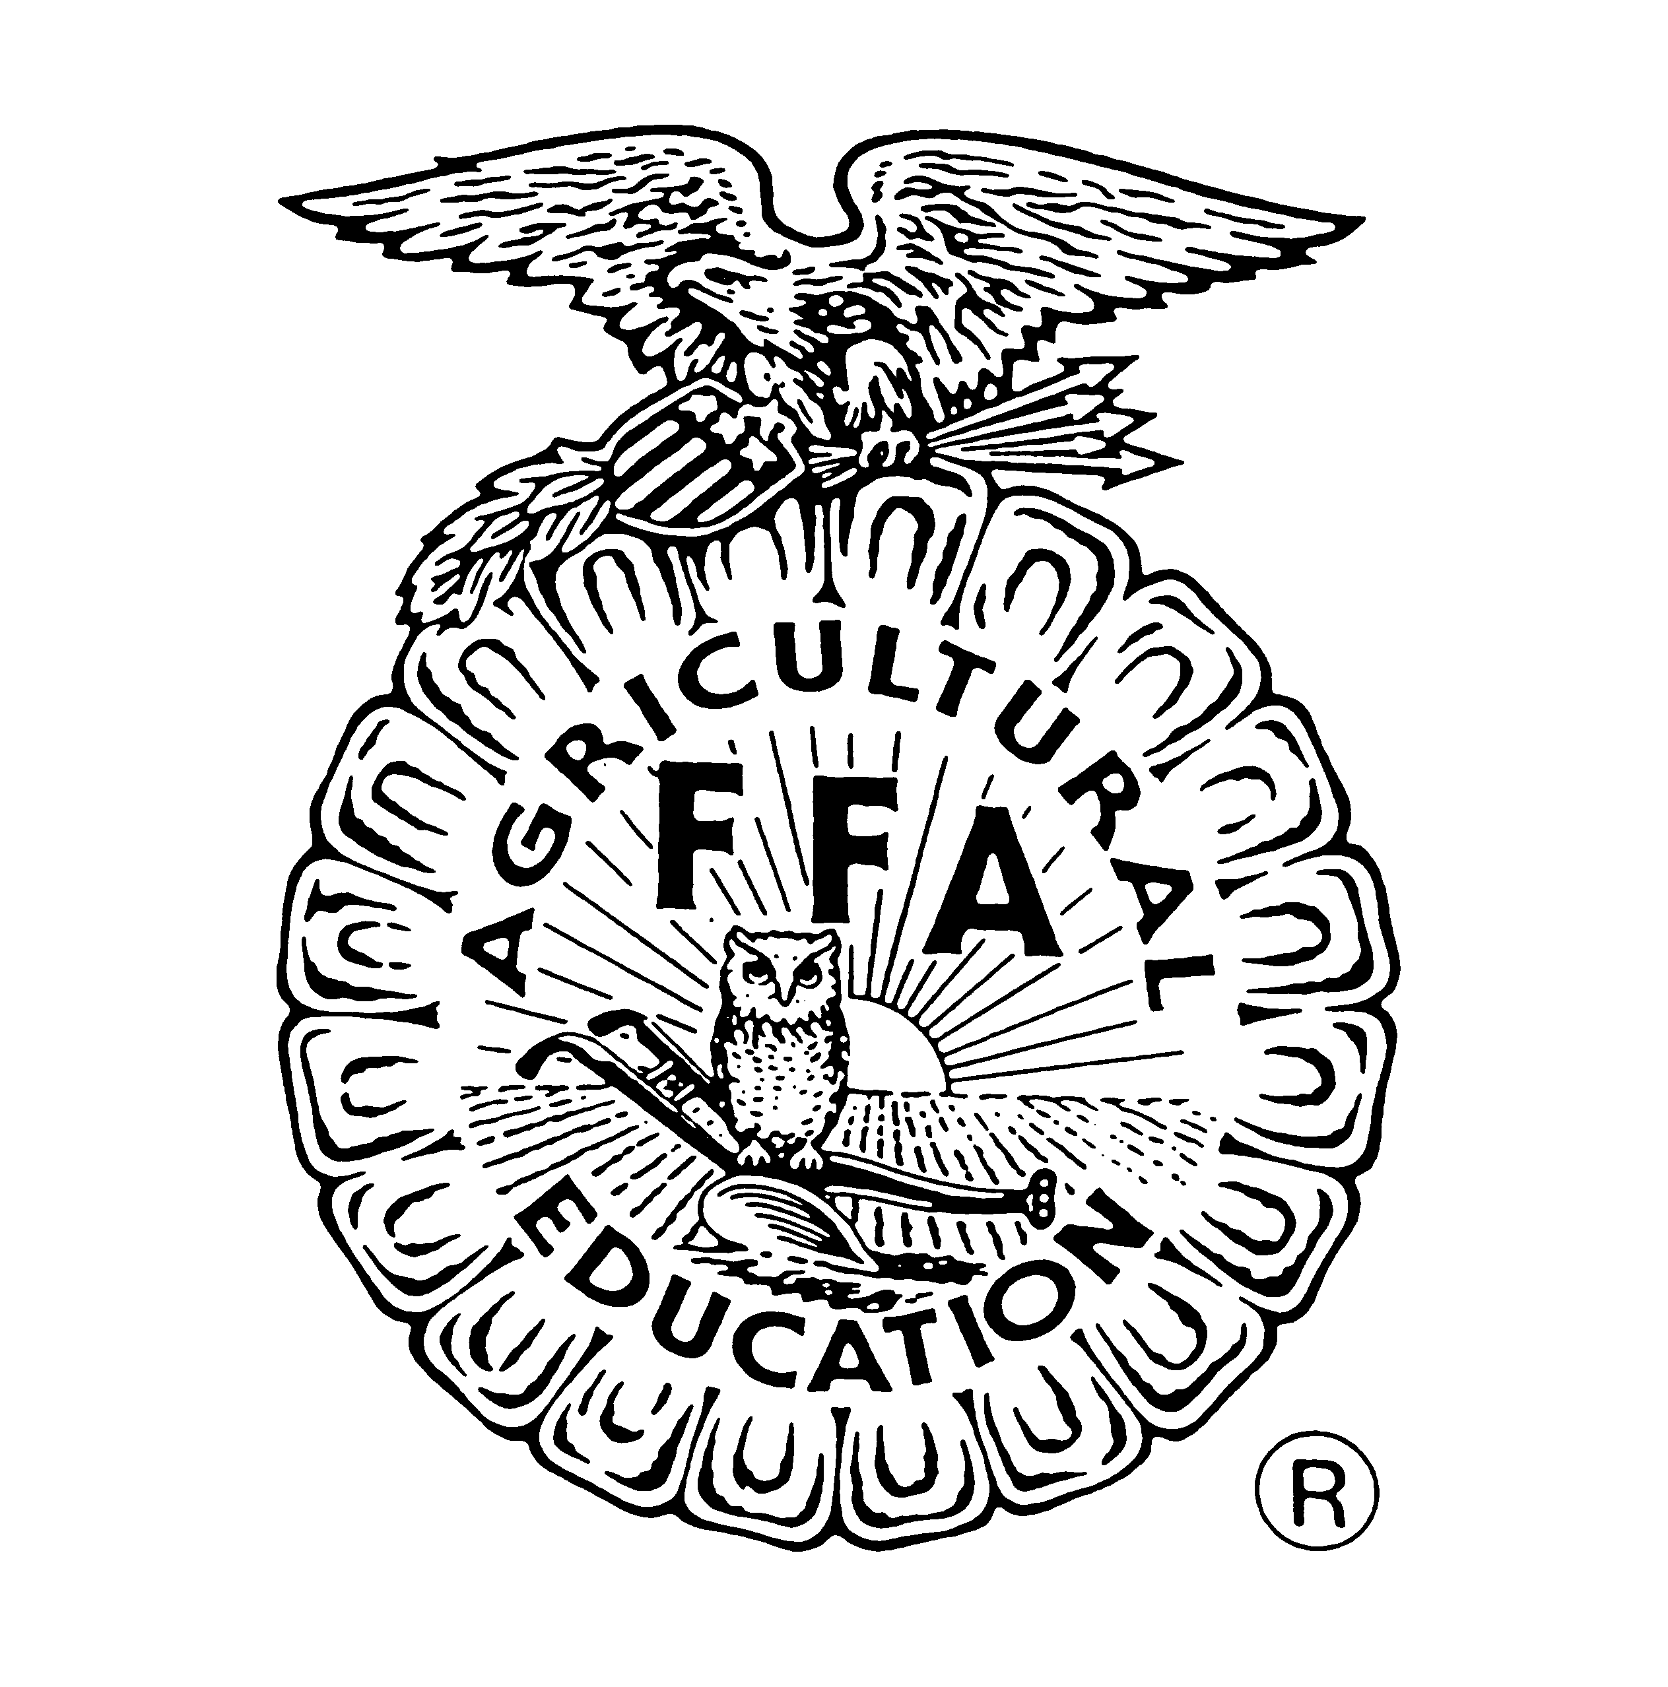

WELDING
CAREER DEVELOPMENT EVENT
RULES AND REGULATIONS
TEAM COMPETITION

ALABAMA FFA ASSOCIATION

TABLE OF CONTENTS

Purpose .................................................................................................................. | 2
Eligibility and Regulations .................................................................................... | 2
Sponsors ............................................................................................................... | 2
Event Rules ............................................................................................................ | 4

Alabama State Department of Education, Philip C. Cleveland, Ed.D., Interim State Superintendent of Education

The Alabama State Board of Education and the Alabama State Department of Education do not discriminate on the basis of race, color, disability, sex, religion, national origin, or age in its programs, activities, or employment and provide equal access to the Boy Scouts and other designated youth groups. The following person is responsible for handling inquiries regarding the non-discrimination policies: Title IX Coordinator, Alabama State Department of Education, P.O. Box 302101, Montgomery, AL 36130-2101, telephone (334) 242-8165.

January 2019
Welding CDE

Welding Career Development Event

PURPOSE:
This event is designed to help students learn more about various welding processes and gain skills needed to further this career path.

ELIGIBILITY AND REQUIRMENTS:
The first 20 FFA Chapters in the North District to sign up may send a MAXIMUM of four members to compete in the contest. How to sign up for the contest and sign up deadline will be sent out prior to the opening date for sign up.

Contestants must meet ALL of the following requirements to be eligible to compete in the contest.
- FFA membership must show as paid to the National FFA Organization for the current year.
- Currently in the 9th grade or higher

District Awards/Sponsors
Calhoun Community College

EVENT GENERAL RULES
- A team shall consist of a maximum of four members. The teams’ total score will be based on the sum of points earned by the three highest participants on the team.

- The contest will consist of each participant doing a plasma cut, T-Joint using GMAW and SMAW, and a paper test.

- If a cell phone is seen or heard in the procession of a competitor, that individual student will be disqualified from the competition.

- Welds, cuts, and tests will be scored by the Calhoun Welding Department instructors. All scores are final.

- Any student that willfully disregards any safety rules posted by the event coordinator will be disqualified.
- Safety glasses must be worn at all times.
- All participants must have full body covering including leather footware, long sleeves, and long pants.
- Handle hot metal with proper tools.
- Proper welding gloves must be worn when welding.

- All participants are responsible for bringing the following equipment: welding hood, safety glasses, chipping hammer, wire brush, welding gloves, jacket or sleeves, tool for handling hot metal. Everything else needed for the contest will be provided

- All welds must be cleaned by hand. Electric grinders are not allowed.

- All welds must be done in the horizontal position.

- Machines will be pre-set. Any participant that is caught changing the setting without permission from a judge will be disqualified.

- Participants must stay with their assigned group. Judges will not attempt to locate a participant that is in the wrong group.

- Participants will have 20 minutes to complete each part of the contest. When time is called all participants must stop.

- All participants will be given a practice piece of steel and the coupon that will be turned in and graded. The 20 minute time limit includes any time that the participant spends on the practice piece. The coupon will be a minimum of 6 inches long.

- FFA advisors, parents, bus drivers, or anyone affiliated with the participants are not allowed in the shop area during the contest.

- Scoring of the welds and plasma cut will be done by a ranking system based off quality.

- In the event of a tie the following order will be used: highest team SMAW score, highest team GTAW score, highest team plasma score, highest team test score.

Contest Layout

The contest will consist of three parts: Plasma Cut, SMAW, GMAW, and a general welding test.

- Plasma Cutting
  - Each participant will cut the design provided by hand. The design will already be drawn on the plate by Calhoun staff. The participant will be scored on cut quality and closeness to original design. Contestants will not be allowed to clean, or chip dross off of their piece. The cut will consist of a straight line cut, circle, and may consist of another design the committee decides. Thickness of material may not exceed ¼ inches.
- General Welding Test
  - Each participant will take the 20 question multiple choice test. The content will be pulled from the test bank used for the Agriculture Mechanics CDE test bank. Only questions that are related to welding will be used.
- SMAW Weld
  - Each participant will complete a 3-Pass weld on one side of the T-Joint coupon. The root pass will be the full length of the coupon. The 2nd pass will be shorter than the root pass and the 3rd pass will be shorter than the 2nd pass. Each participant’s coupon will have marks where each weld is to stop.
- GTAW Weld
  - Each participant will complete a 3-Pass weld on the opposite side of the T-Joint coupon from the SMAW weld. The root pass will be the full length of the coupon. The 2nd pass will be shorter than the root pass and the 3rd pass will be shorter than the 2nd pass. Each participant’s coupon will have marks where each weld is to stop.
  - Each participant will receive one T-Joint coupon to turn in to be graded. One side will be used for GTAW and the other will be used for SMAW

